**Currency Exchange Rate Prediction**

**Objective:-**

The linear regression model was developed to predict the **closing prices** of the Nifty 50 index using historical data. The dataset contained financial indicators such as **Open**, **High**, **Low**, **Volume (Vol.)**, and **Change %** as features for the model.

**Let’s Explain the code :-**

* **Data Preprocessing** :

1. Cleaned and converted data columns to numerical formats.
2. Handled volume and percentage formats for proper analysis.
3. Sorted data chronologically for consistent predictions.

* **Model Training and Evaluation** :

1. The dataset was split into training (80%) and testing (20%) subsets.
2. A linear regression model was trained using the training data.
3. **Evaluation Metrics**:
   1. Mean Squared Error (MSE): **35544.04385779718**
   2. R² Score: 0.9924885623917066 (These metrics indicate excellent performance, with the model explaining ~99.25% of the variance in the data.)

* **Visualization**:
* A scatter plot with a trend line showed a strong correlation between actual and predicted prices, validating the model’s accuracy.

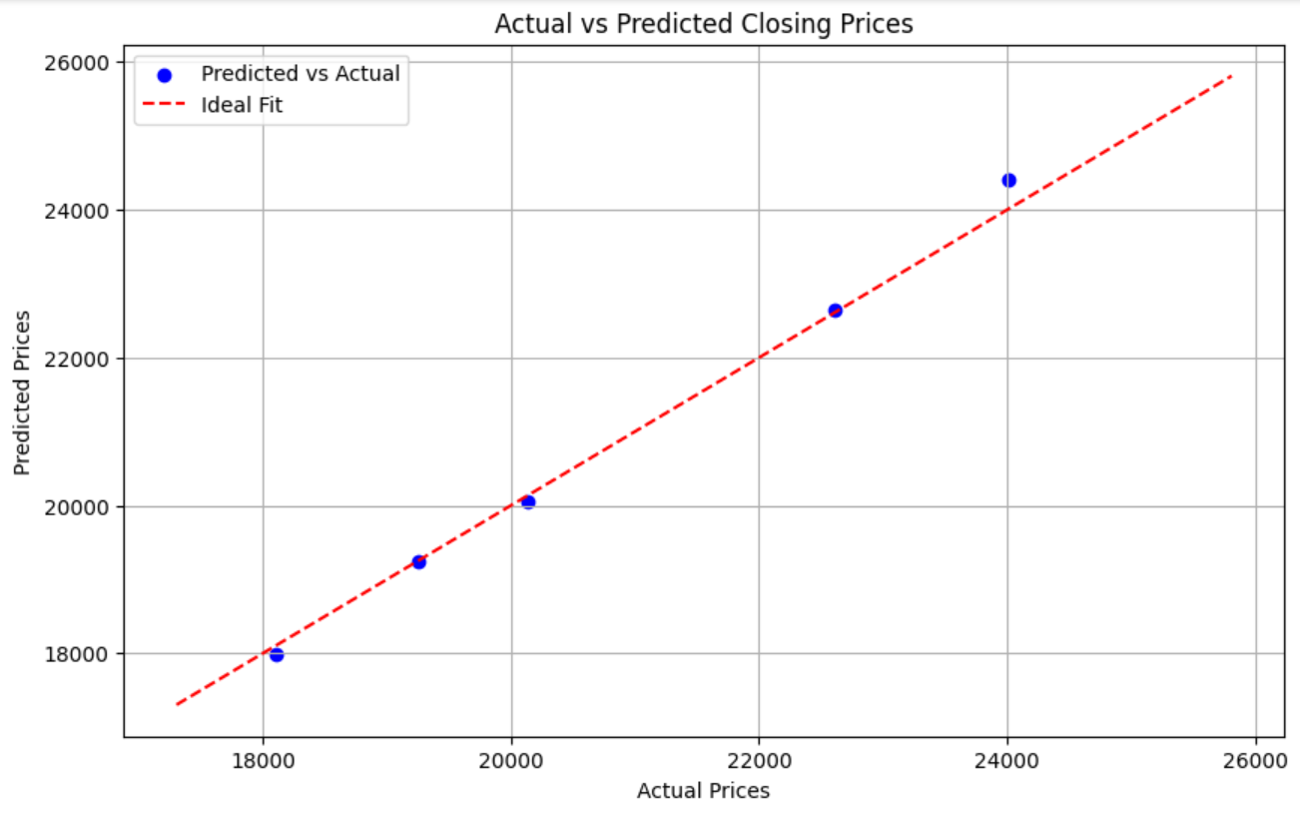

* **Additional Predictions**:

1. Predictions for new data points demonstrated the model's ability to generalize:
   1. Example Input:
      1. Open: 18,500.0
      2. High: 18,800.0
      3. Low: 18,200.0
      4. Vol.: 5.5 billion
      5. Change %: 0.5
   2. Predicted Closing Price: 18551.465204.

